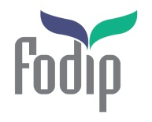
THE FORUM FOR DISCUSSION OF ISRAEL AND PALESTINE
REG. CHARITY 1139005
Women’s Voices Project

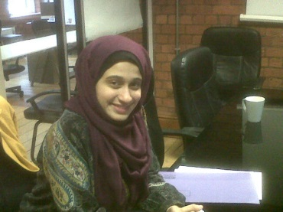
Who is a Women’s Voices participant?
- Enthusiastic about bringing diverse people together.
- Enjoys working in a team.
- Is looking to develop her skills and learn new things.
- Interested in helping to run a social action project.
- Has personal integrity and moral character.

Mrs Alaa Elaydi, Project Co-ordinator

What do participants commit to?
- Attend a 2 day residential.
- Attend three 2-hour training workshops on project design and facilitation skills.
- Invest in fortnightly project organising meetings.
- Create 2 short reflection blogs, and 1 vlog entry on their experiences during the project.
- Take part in the two-phase evaluation process at the end of the project.

What do participants gain?
- Personalised mentoring in leadership and activism by a FODIP project member.
- Project organising skills: Skills and experience in designing, running and managing successful projects.
- Professional skills: As part of the project, participants will develop their skills in presentations and marketing.
- Basic conflict resolution skills: Skills in facilitating difficult discussions and constructing safe spaces.
- Activist and leadership skills: Ability to facilitate diverse groups and influence people and institutions positively to make positive change. There will also be sessions on aspects of women and leadership, and issues around civic engagements.
- Networking: Access to networks of regional and national interfaith leaders for sharing ideas and contacts.
- The possibility of travelling to Israel/Palestine to view women’s projects.

For further information, please contact Alaa either by email: projects@fodip.org or telephone either Alaa direct: 07740107563 or the main FODIP office: 01865 787458

(This project is sponsored by the Paul Hamlyn Foundation)

The Forum for Discussion of Israel and Palestine
Watlington Road, Cowley, Oxford OX4 6BZ info@fodip.org www.fodip.org

